CICS Setup Reference

CICS Setup Reference
Below is a checklist that you need to follow.

Activities need to be performed
- CICS libraries and HLQ (CICS and CPSM libraries)
- CICS SIT and EYU Parms settings
- CICS Proclib (CICS Startup JCL)
- CICS VTAM definition (Appl)
- Sample job to define ALIAS
- Jobs to define new CICS regions (DFHCMACI, DEFCOMDS, DEFDEFDS, DFHILG7)
- MQ Libraries and HLQ
- DB2 Libraries and HLQ

The below are the libraries HLQ that users will be required to know for the purpose of definitions and customization.

- CICS Libraries
CICS HLQ begins with DFH550.CICS.** libraries as per sample screenshot below.
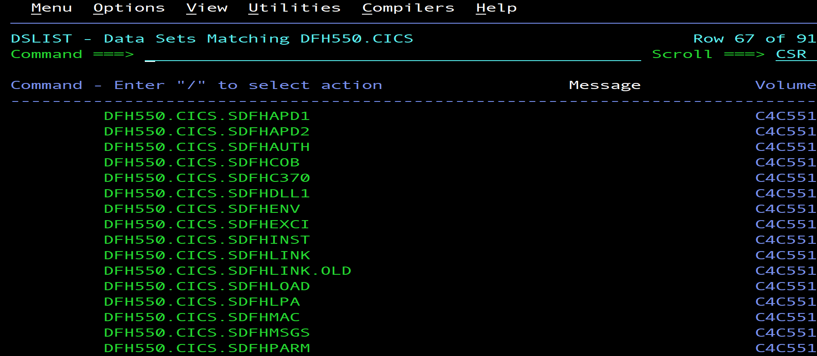

For CICS CPSM libraries, the HLQ will be DFH550.CPSM.** as per screenshot below.
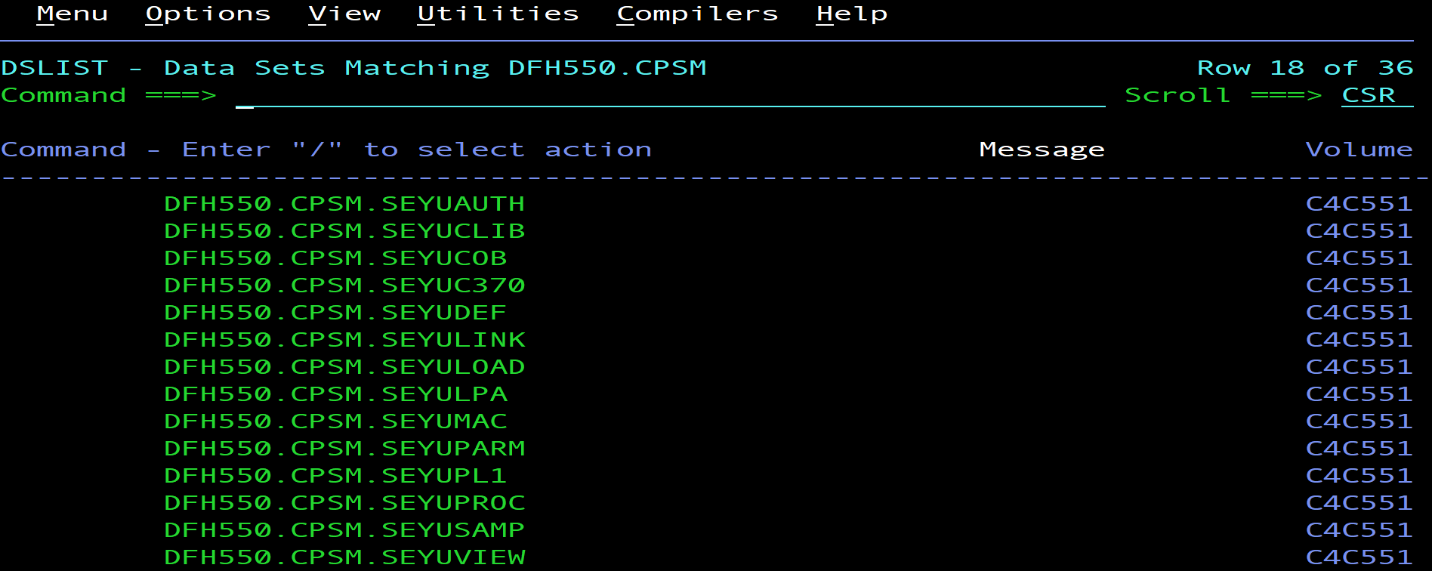

- CICS SIT and EYU Parms settings
All CICS definition parameters are located in Library (DFH550.CICS.SITLIB).
We can find all CICS SIT Parms and EYU Parms settings this this library.

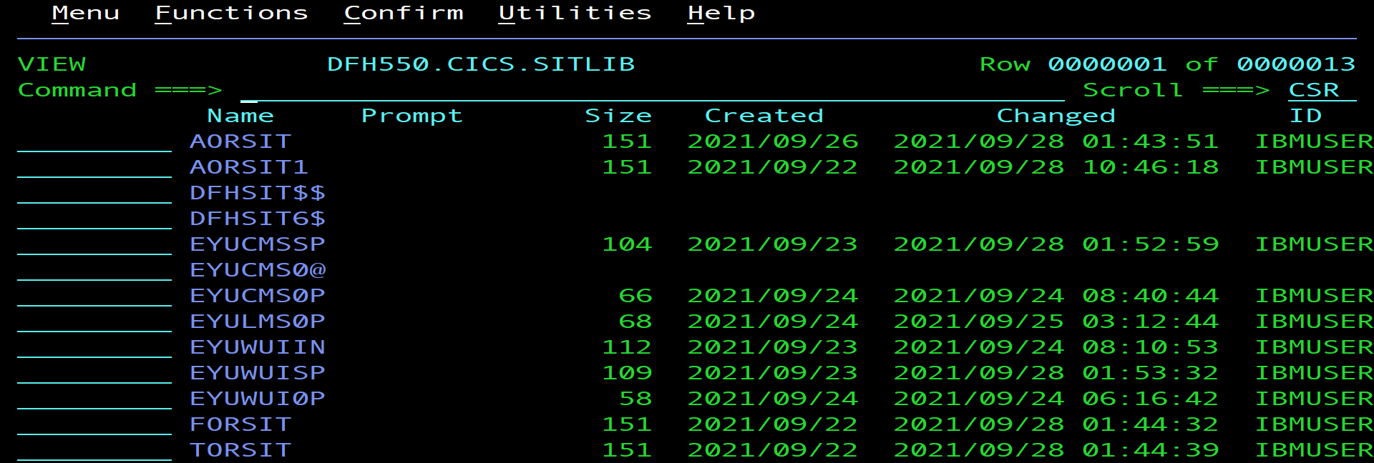

- CICS STC Proclib
All CICS atarter task JCL is located in this library.

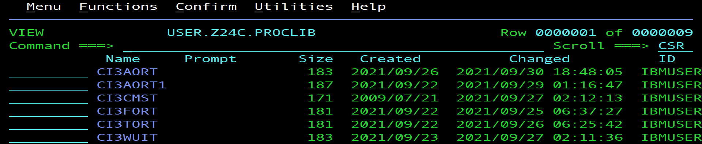

- VTAM definition for CICS Applid ID
The VTAM definition for the CICS APPL can be found in this library with the menber name(CICSAPPL).

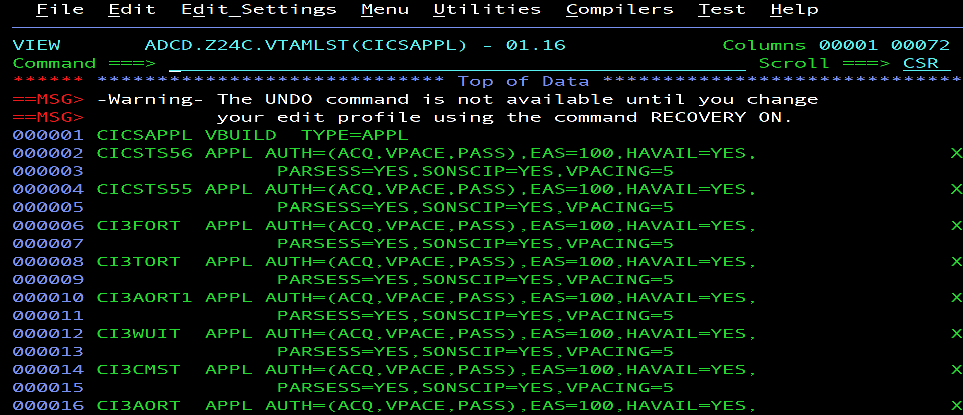

- Job to define Alias
The Job to define Alias can be located in DFH550.CICS.XDFHINST(DEFALIAS).
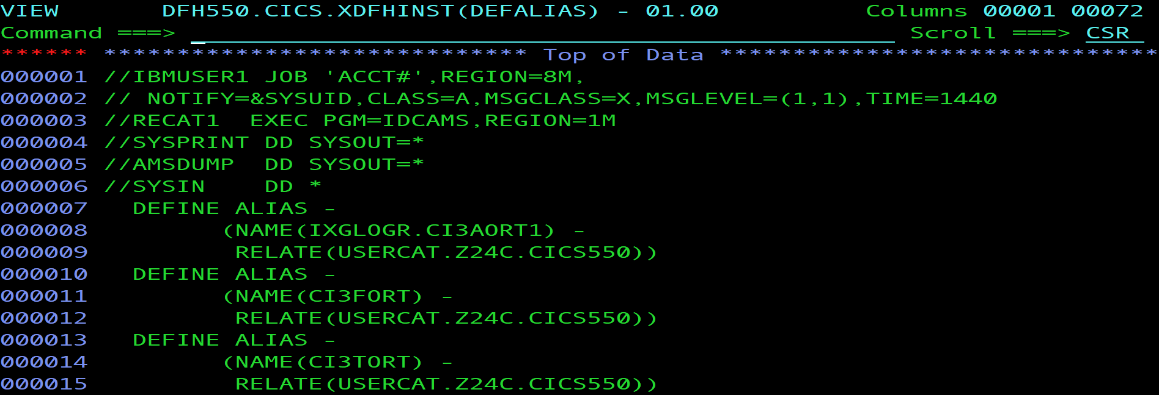

- Jobs to define New CICS regions
The Jobs to define new CICS regions are located in the library below. DFH550.CICS.XDFHINST (DFHCMACI).
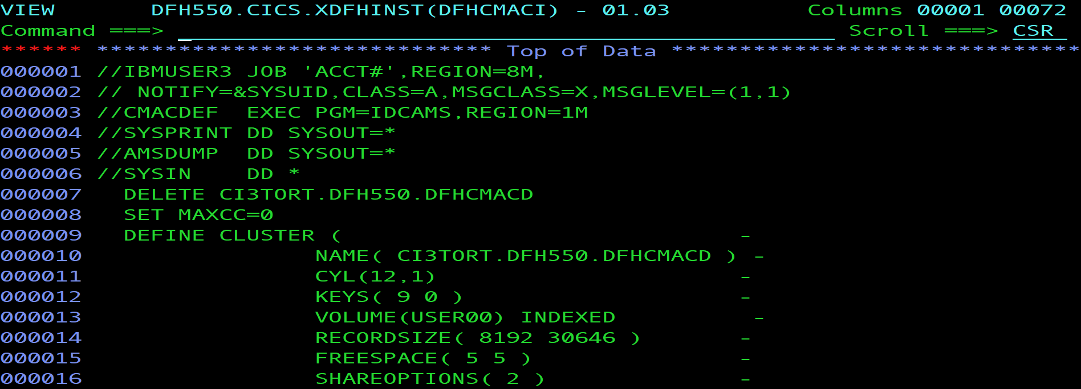

DFH550.CICS.XDFHINST (DFHCOMDS).
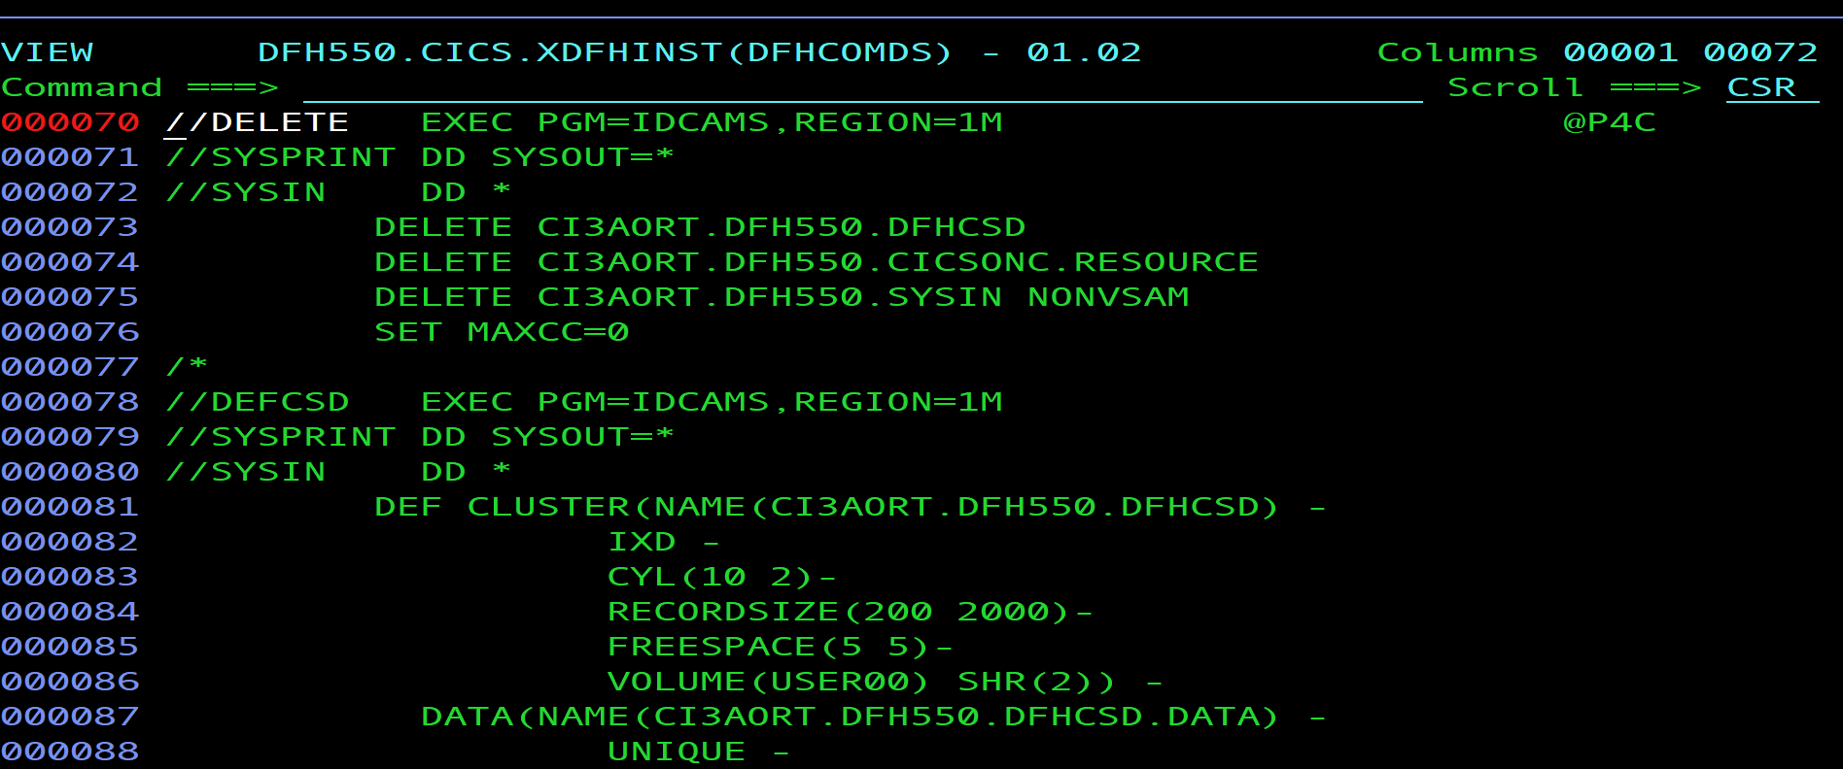

DFH550.CICS.XDFHINST (DFHDEFDS)
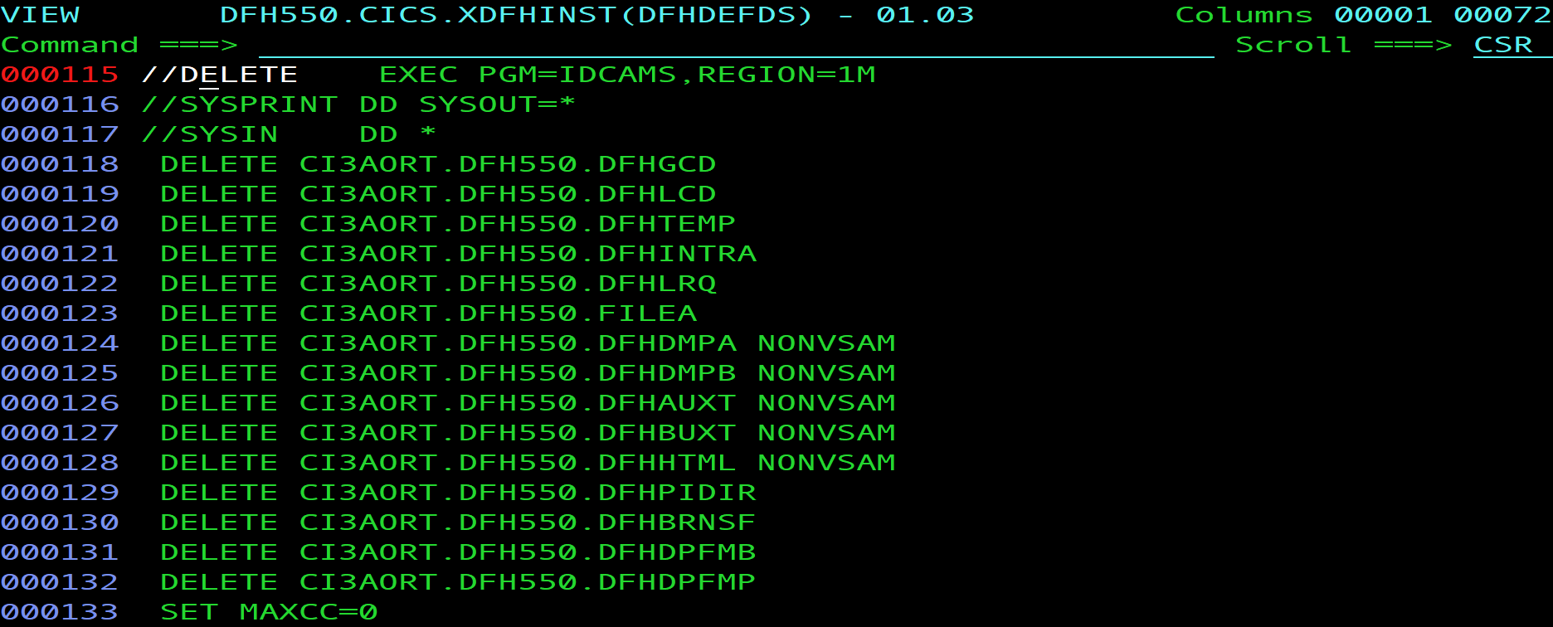

DFH550.CICS.XDFHINST (DFHILG7)
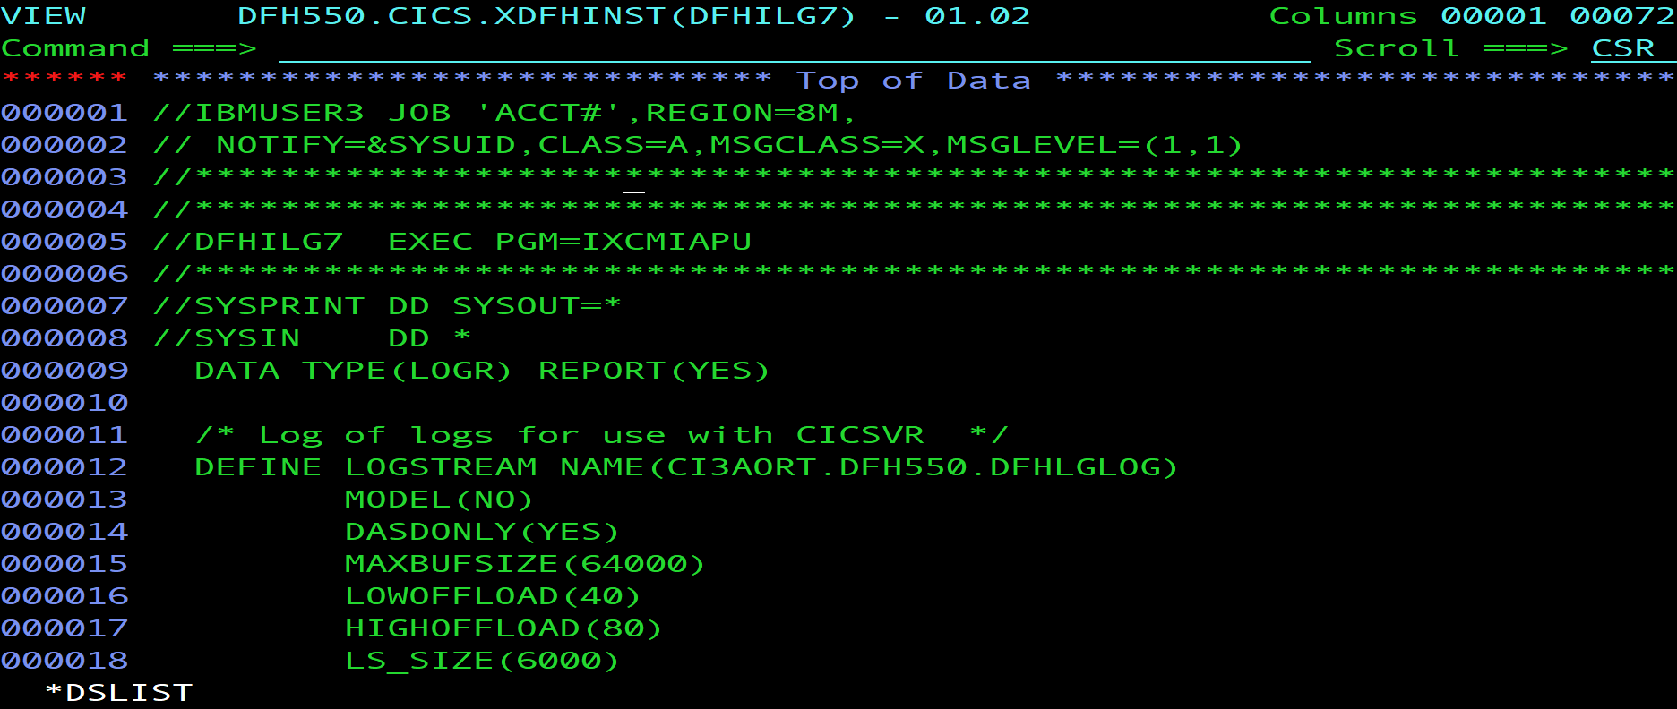

- MQ HLQ Libraries
MQ HLQ begins with CSQ911.** libraries as per sample screenshot below.

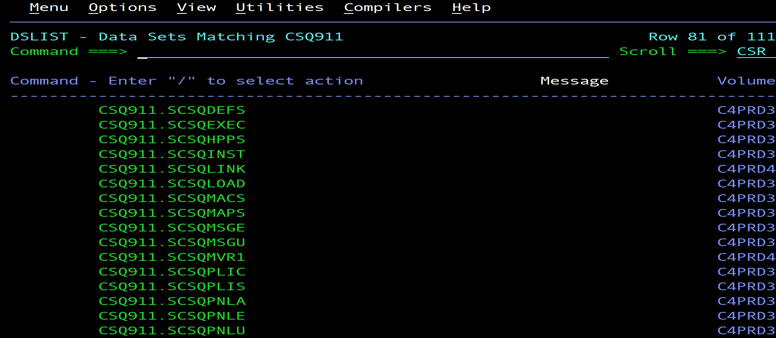

- DB2 HLQ Libraries
DB2 HLQ begins with CSQ911.** libraries as per sample screenshot below.

